Import Data using Transform Maps (Spreadsheet)

Brainstorming & Ideation Phase
Phase 1: Prepare the sheets
Problem Identification:
Organizations often receive large amounts of employee information in Excel spreadsheets. Manually entering this data into ServiceNow is time-consuming and may result in data-entry errors. A systematic approach is required to import employee records quickly, accurately, and consistently.
Proposed Solution:
The project proposes using ServiceNow Import Sets and Transform Maps to automate the employee data import process. The Excel spreadsheet will be uploaded into an Import Set table, where the data will be temporarily stored. A Transform Map will then be created to map the spreadsheet fields to the corresponding fields in the target employee table.
Key Ideas:
- Collect employee data in an Excel spreadsheet.
- Load the spreadsheet into ServiceNow using Import Sets.
- Use an Import Set table as a temporary staging area.
- Create a Transform Map for field mapping.
- Map source fields to appropriate target fields.
- Execute the transformation process.
- Verify that employee records are successfully created.
- Validate the imported data for accuracy and completeness.
Expected Outcome:
The proposed solution will provide a simple and efficient method for importing bulk employee data into ServiceNow while reducing manual effort and improving data accuracy. It will also give beginners practical knowledge of the complete Import Set → Transform Map → Transformation → Validation workflow.

Prepare the sheets

- Open New Google Spreadsheet
- Create New Google Spreadsheet with sample data as shown below
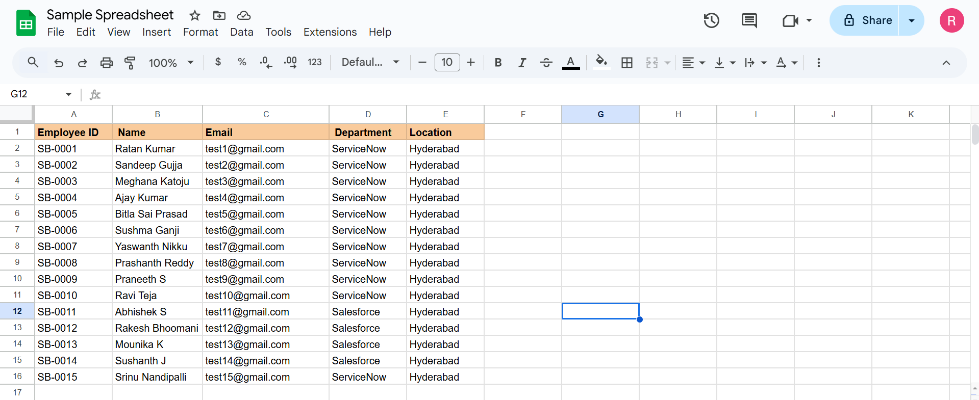
- Download the spreadsheet as Sample Spreadsheet.xlsx format.
